WoHist – AL Name: _________________________
Unit #3: The Early ModernWorld Period: ___ Date: ___________

Text of Mayflower Compact:

In the name of God, Amen.
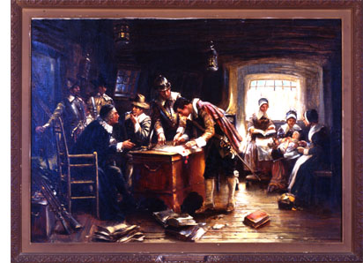
We whose names are under-written, the loyal subjects of our dread sovereign Lord, King James, by the grace of God, of Great Britain, France, and Ireland King, Defender of the Faith, etc. Having undertaken, for the glory of God, and advancement of the Christian faith, and honor of our King and Country, a voyage to plant the first colony in the northern parts of Virginia, do by these presents solemnly and mutually, in the presence of God, and one of another, covenant and combine our selves together into a civil body politic, for our better ordering and preservation and furtherance of the ends aforesaid; and by virtue hereof to enact, constitute, and frame such just and equal laws, ordinances, acts, constitutions and offices, from time to time, as shall be thought most meet and convenient for the general good of the Colony, unto which we promise all due submission and obedience. In witness whereof we have hereunder subscribed our names at Cape Cod, the eleventh of November [New Style, November 21], in the year of the reign of our sovereign lord, King James, of England, France, and Ireland, the eighteenth, and of Scotland the fifty-fourth. Anno Dom. 1620.

John Carver
William Brewster
John Alden
William Mullins
John Craxton
John Howland
John Tilly
Thomas Tinker
John Turner
Digery Priest
Edmond Margeson
Richard Clark
Thomas English
John Goodman
William Bradford
Isaac Allerton
Samuel Fuller
William White
John Billington
Steven Hopkins
Francis Cook
John Rigdale
Francis Eaton
Thomas Williams
Peter Brown
Richard Gardiner
Edward Doten
George Soule
Edward Winslow
Miles Standish
Christopher Martin
James Chilton
Richard Warren
Edward Tilly
Thomas Rogers
Edward Fuller
Moses Fletcher
Gilbert Winslow
Richard Bitteridge
John Allerton
Edward Liester

Study Questions: work in groups of two (2) to answer the questions below.
- In what two (2) “presences” is this document being signed?
- What is being promised in the document and by whom?
- What does it mean by the words, “covenant and combine”?
- What do the signers mean by a "civil body politic"?
- What was the purpose of the document?
- Why might some of the passengers have believed a document like the Mayflower Compact was necessary?
- Identify words, expressions, and/or ideas in the Mayflower Compact that we use today as part of our government.
- Look at the Code of Hammurabi (I hope you still have the copy!) and list five ways that the Mayflower Compact resembles Hammurabi’s Code. Stretch your minds on this one!

These questions are Copyright © 1999 Houghton Mifflin Company. All Rights Reserved

WoHist – AL Name: _________________________
Unit #3: The Early ModernWorld Period: ___ Date: ___________

Mayflower Compact Essay:

Use the rubric below to answer one (1) of the following essay questions (Your teacher will assign it to you).
Add Rubric

Essay Questions:

- Some historians suggest that the Mayflower Compact is simply a copy of the Code of Hammurabi, just updated for modern times. Assess the validity of this question.

- “The goals of William Bradford had in mind when writing the Mayflower Compact were similar to the goals of Hammurabi when he wrote his Code of Law.” Would you agree or disagree with this quote?

- Using the Code of Hammurabi and the Mayflower Compact as examples, list and define four (4) key elements necessary for successful government.

- Which of the documents, the Code of Hammurabi or the Mayflower Compact was more successful in accomplishing its goals.

- Which would you have rather lived under, the Code of Hammurabi or the Mayflower Compact? Why?

